3D:Biochemical Characteristics

Members:
Aleia Quilang
Thea Marie Quinto
Jose Angelo Recio
Jirah Angelica Refuerzo
Andreu Robles
Joanne Claire Rodriguez
Mavourneen Tracy Chanel Romero
Muriel Fay Samonte

Introduction:
Biochemical Testing is one of the most important things that microbiologists always consider in identifying and observing a microorganism. It is a procedure where one can identify the growth, metabolism and defences of a specific microorganism. And so with the help of this type of experiment faster performances and more vivid data are produced.

Objectives:
- To identify the different biochemical reactions and what each reaction indicates/ is used for.

Results:

SIMMONS CITRATE AGAR- A positive reaction is indicated by growth on the slant with an intense blue color (alkaline reaction). A negative reaction is indicated by inhibition to poor growth without change in color (medium remains green).
LYSINE IRON AGAR- A positive lysine decarboxylase reaction is purple (alkaline) butt, purple slant. A negative reaction is yellow (acid) butt, purple (alkaline) slant. A positive lysine deaminase reaction is a red slant. A negative reaction is a purple slant. A positive hydrogen sulfide reaction is blackened medium at the apex of the slant.
TRIPLE SUGAR IRON AGAR- An alkaline slant-acid butt (red/yellow) indicates fermentation of dextrose only. An acid slant-acid butt (yellow/yellow) indicates fermentation of dextrose, lactose and/or sucrose. An alkaline slant-alkaline butt (red/red) indicates dextrose or lactose were not fermented (non-fermenter). Cracks, splits, or bubbles in medium indicate gas production. A black precipitate in butt indicates hydrogen sulfide production.
SIM MEDIUM- Motility is indicated by turbidity of the medium or growth extending from inoculating stab line. H2S production is shown by a blackening along the stab line. Indole production is seen as the production of a red color after the addition of Kovac’s Reagent. Indole is produced from the tryptophane present in the medium.
MR-VP BROTH-
Methyl Red (MR) Test: Positive – bright red color; Negative – yellow-orange color
Voges-Proskauer (VP) Test: Positive – red color, Negative – no red color.
UREASE TEST - A positive urease test using urea broth. A positive urease test is indicated by a color change to bright pink (fuchsia). A negative urease test using urea broth. A negative urease test is indicated by the yellow coloration of the media.

Test: Simmons Citrate Test

Medium | Bacteria Number | Usual Medium Color | Result/ Change
Simmons Citrate | CR-8 | Green | -
Simmons Citrate | CR-9 | Green | -
Simmons Citrate | A-1 | Green | -
Simmons Citrate | A-21 | Green | -
Simmons Citrate | A-22 | Green | +

Test: Lysine Iron Agar Test

Medium | Bacteria Number | Usual Medium Color | Result/ Change
Lysine Iron Agar | CR-8 | Purple | -
Lysine Iron Agar | CR-9 | Purple | -
Lysine Iron Agar | A-1 | Purple | -
Lysine Iron Agar | A-21 | Purple | +
Lysine Iron Agar | A-22 | Purple | +

Test: Triple Sugar Iron Test

Medium | Bacteria Number | Usual Medium Color | Result/ Change
Triple Sugar Iron | CR-8 | Red | + (yellow butt)
Triple Sugar Iron | CR-9 | Red | +(yellow butt)
Triple Sugar Iron | A-1 | Red | +( yellow butt)
Triple Sugar Iron | A-21 | Red | +( orange)
Triple Sugar Iron | A-22 | Red | +(yellow butt)

Test: Sulfur Indole Motility Test

Medium | Bacteria Number | Usual Medium Color | Result/ Change
SIM Medium | CR-8 | Pale yellow | + (spread)
SIM Medium | CR-9 | Pale yellow | +(spread)
SIM Medium | A-1 | Pale yellow | +(spread)
SIM Medium | A-21 | Pale yellow | -
SIM Medium | A-22 | Pale yellow | -

Test: Voges Proskauer Test

Medium | Bacteria Number | Usual Medium Color | Result/ Change
Voges Proskauer | CR-8 | Urine yellow | +
Voges Proskauer | CR-9 | Urine yellow | +
Voges Proskauer | A-1 | Urine yellow | +
Voges Proskauer | A-21 | Urine yellow | +
Voges Proskauer | A-22 | Urine yellow | +

Test: Urea

Medium | Bacteria Number | Usual Medium Color | Result/ Change
Urea | CR-8 | Red | -
Urea | CR-9 | Red | -
Urea | A-1 | Red | -
Urea | A-21 | Red | -
Urea | A-22 | Red | -

Test: MR-VP (Methy Red)

Medium | Bacteria Number | Usual Medium Color | Result/ Change
Methyl Red | CR-8 | Pale yellow | + (Red ring at the top)
Methyl Red | CR-9 | Pale yellow | -
Methyl Red | A-1 | Pale yellow | + (Red ring at the top)
Methyl Red | A-21 | Pale yellow | + (Red ring at the top)
Methyl Red | A-22 | Pale yellow | + (Red ring at the top)

Pictures:

Test: Simmons Citrate Test

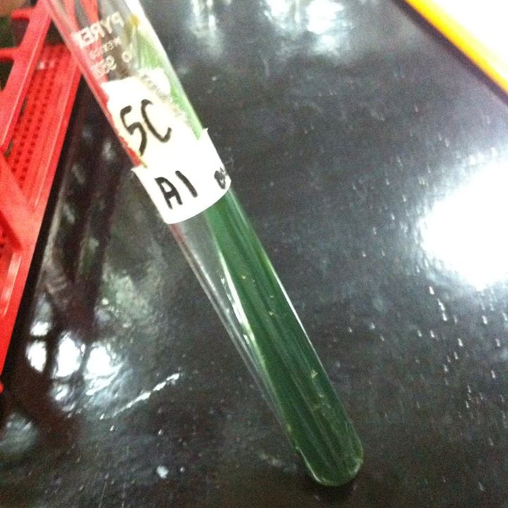
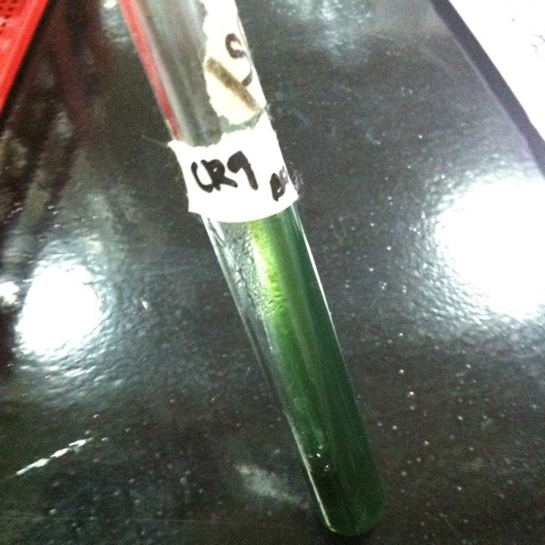
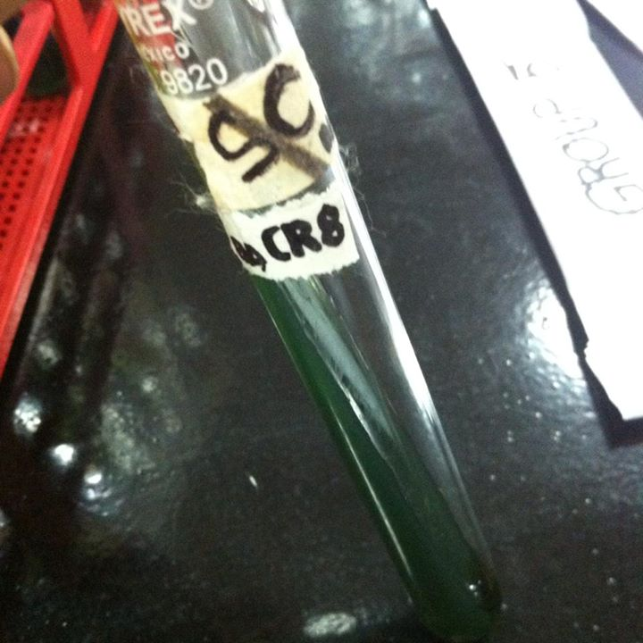

CR-8 CR-9 A-1

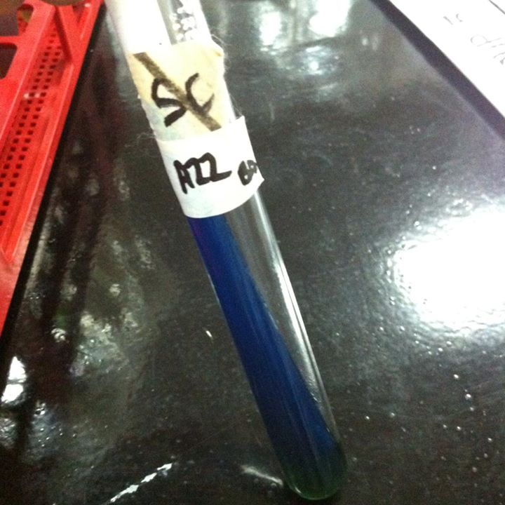
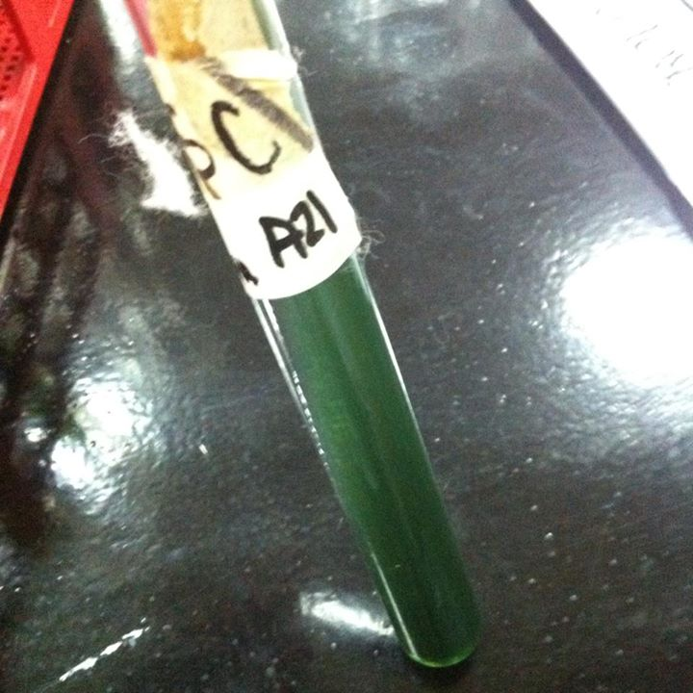

A-21 A-22

Test: Lysine Iron Agar Test

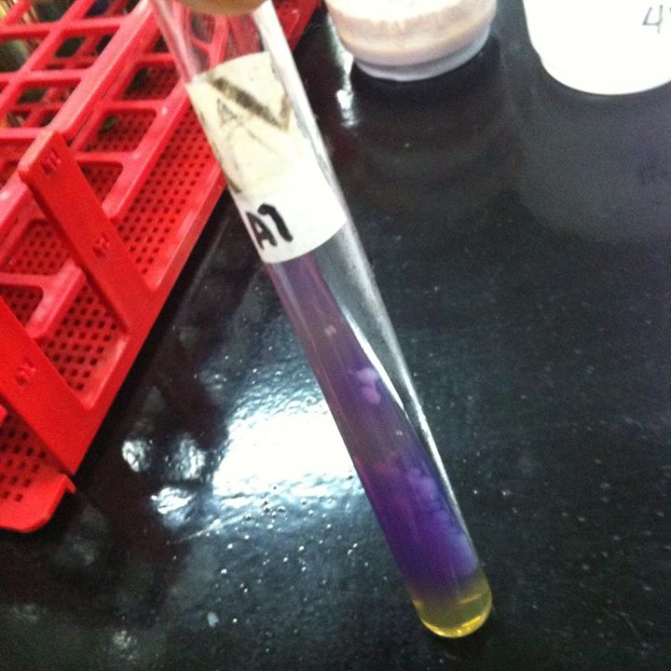
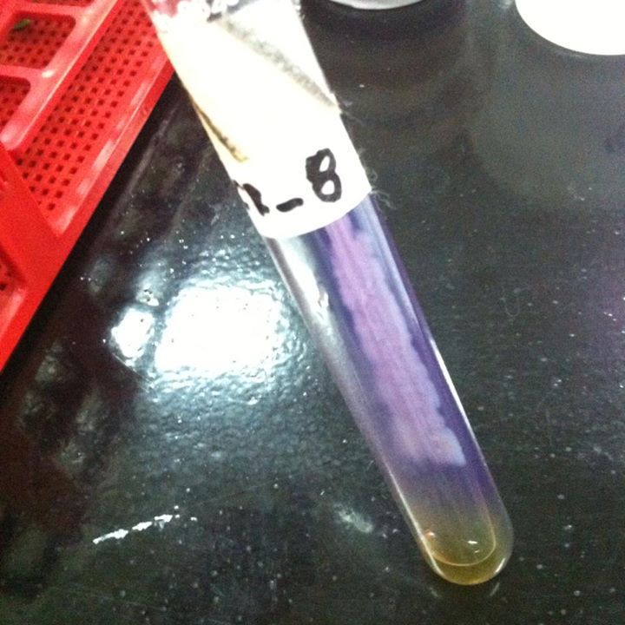
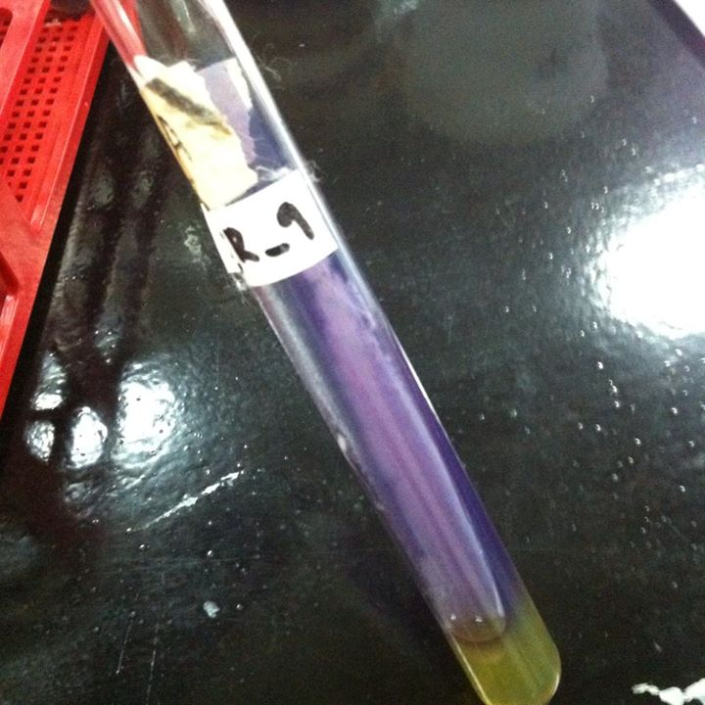

CR-8 CR-9 A-1

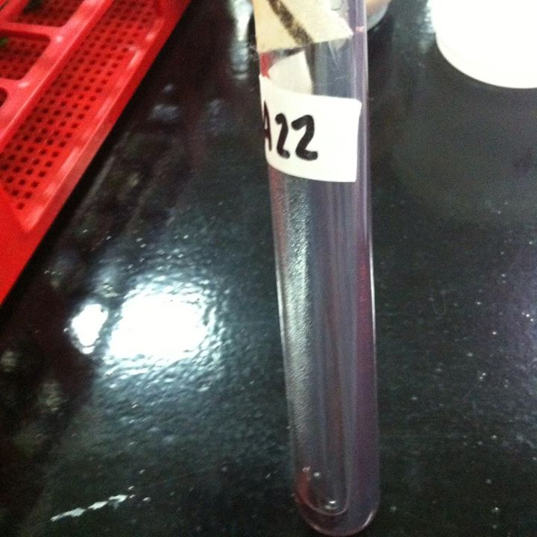
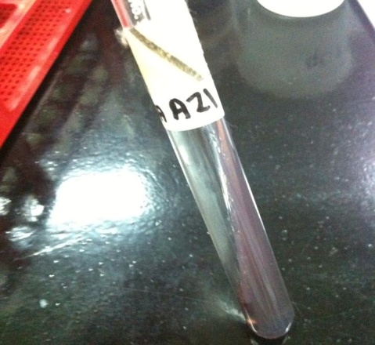

A-21 A-22

Test: Triple Sugar Iron Test

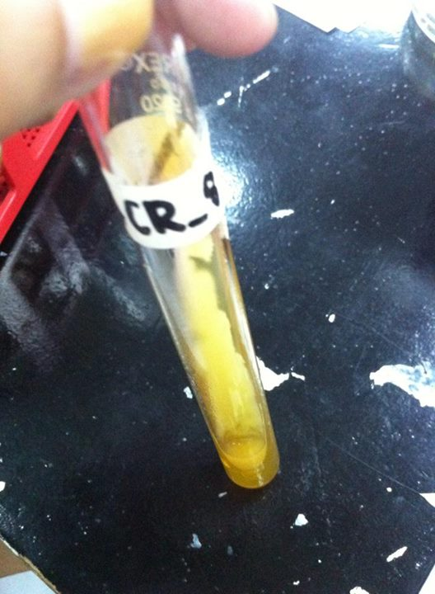
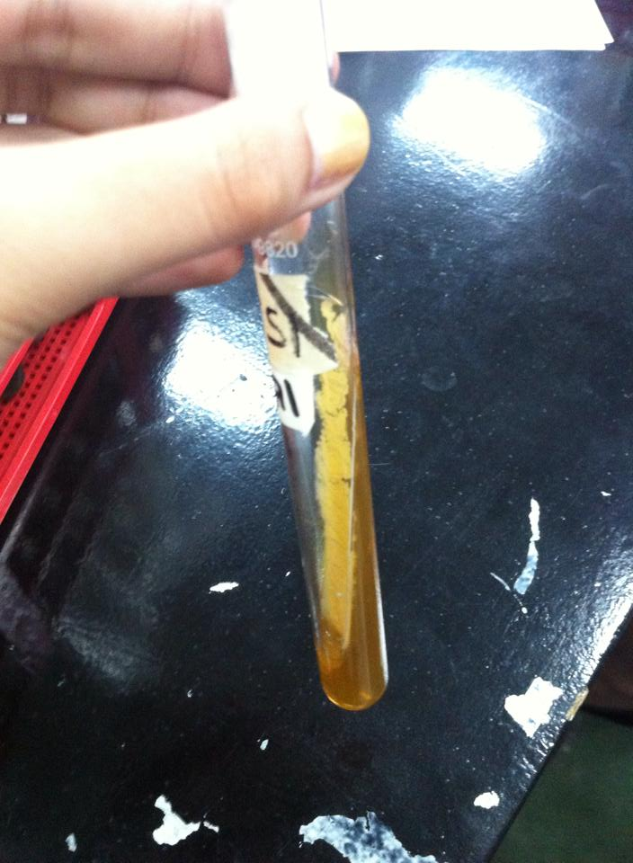
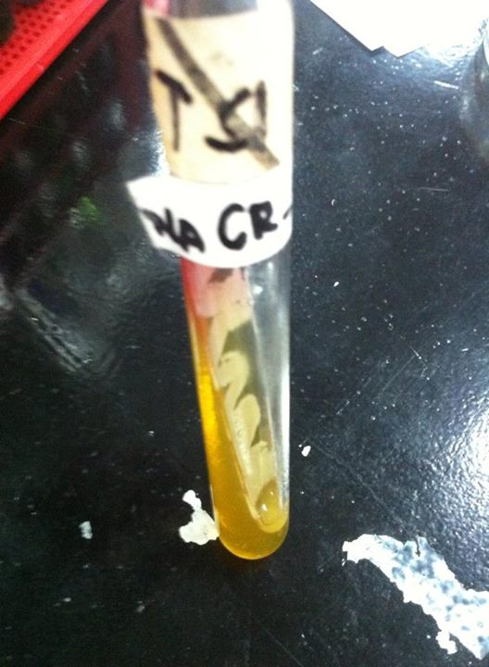

CR-8 CR-9 A-1

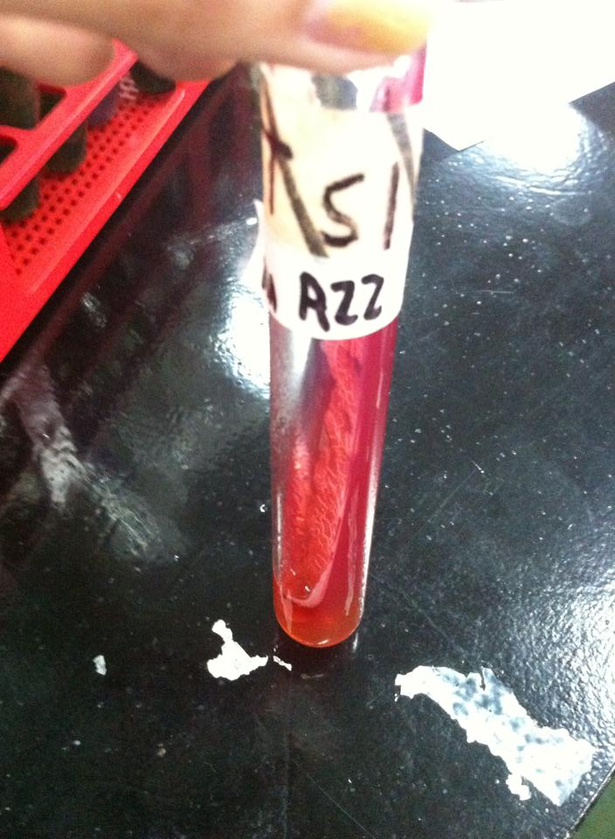
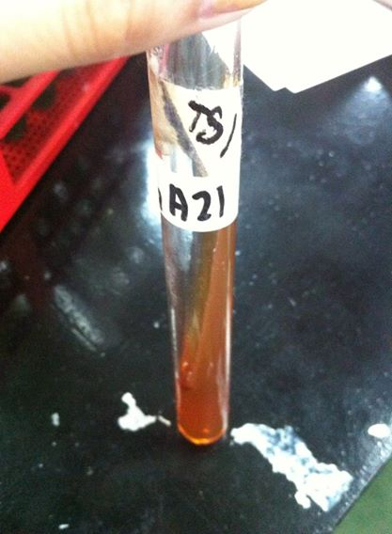

A-21 A-22

Test: Sulfur indole Motility Test
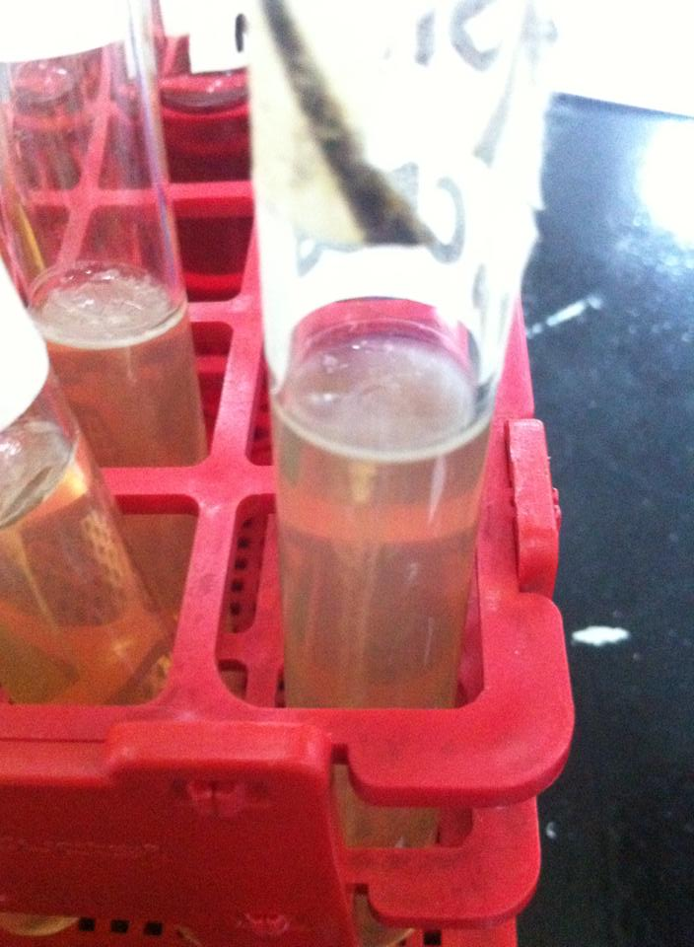
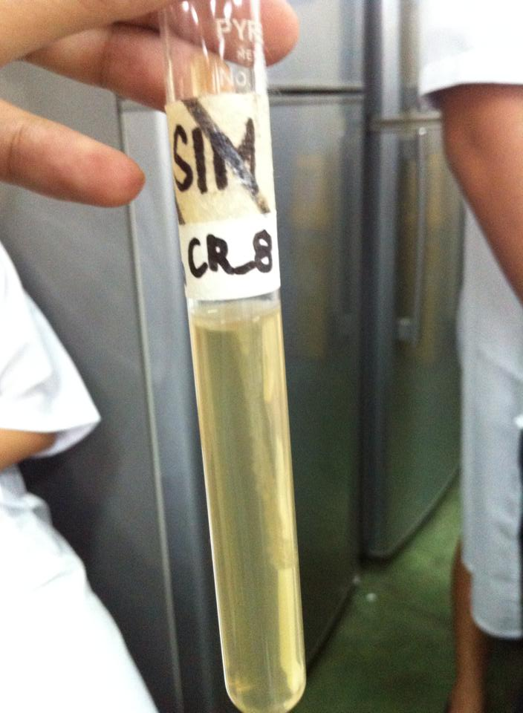

CR-8

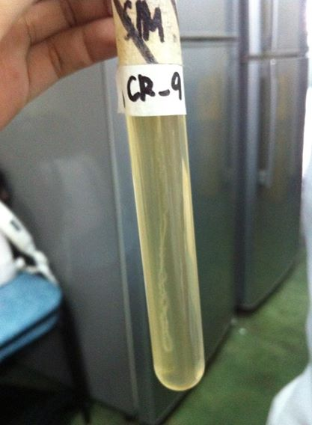
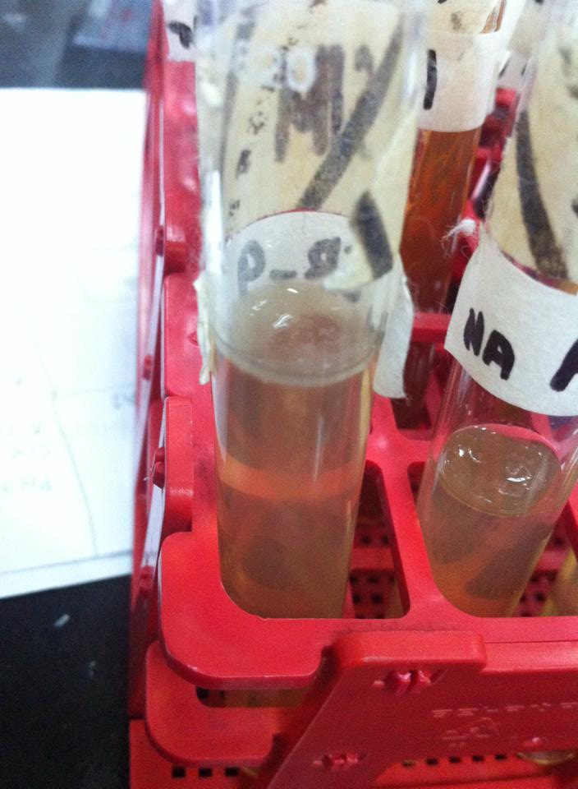

CR-9

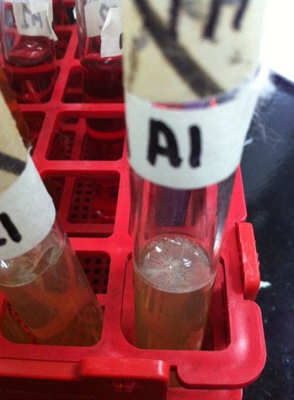
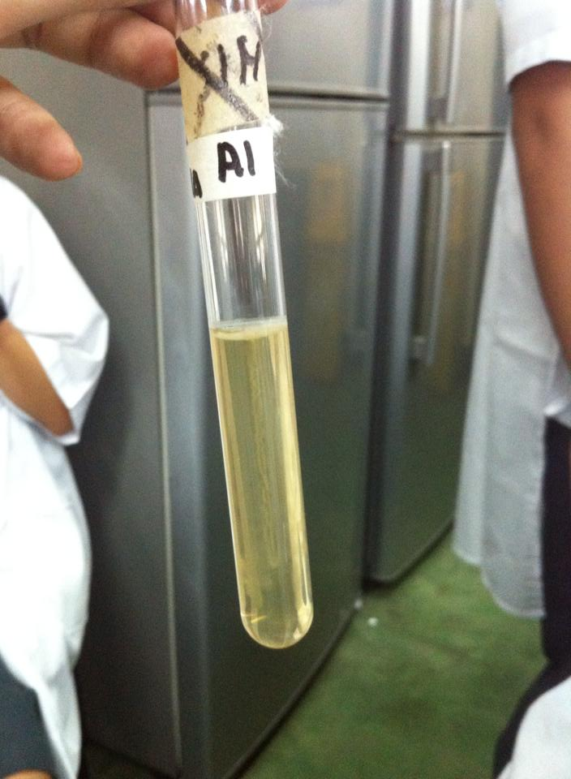

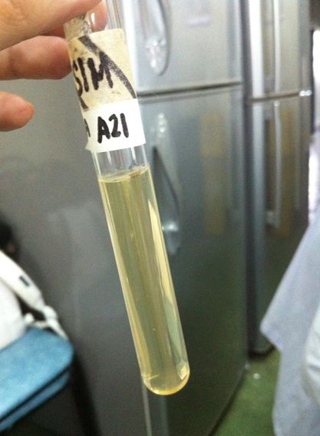
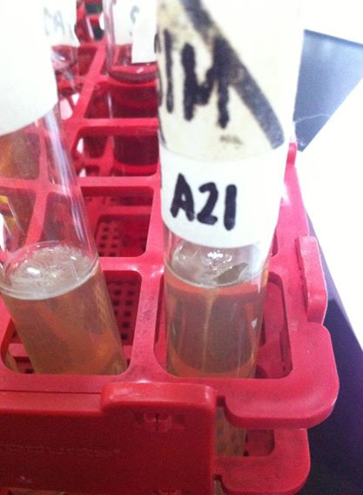

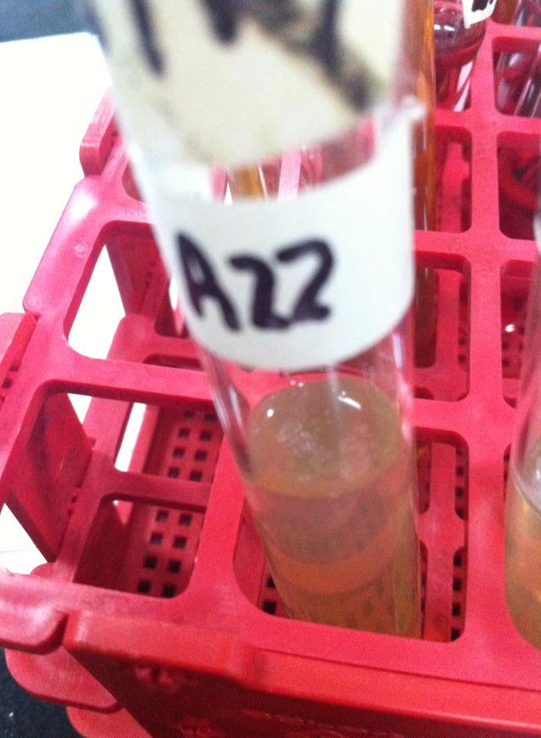
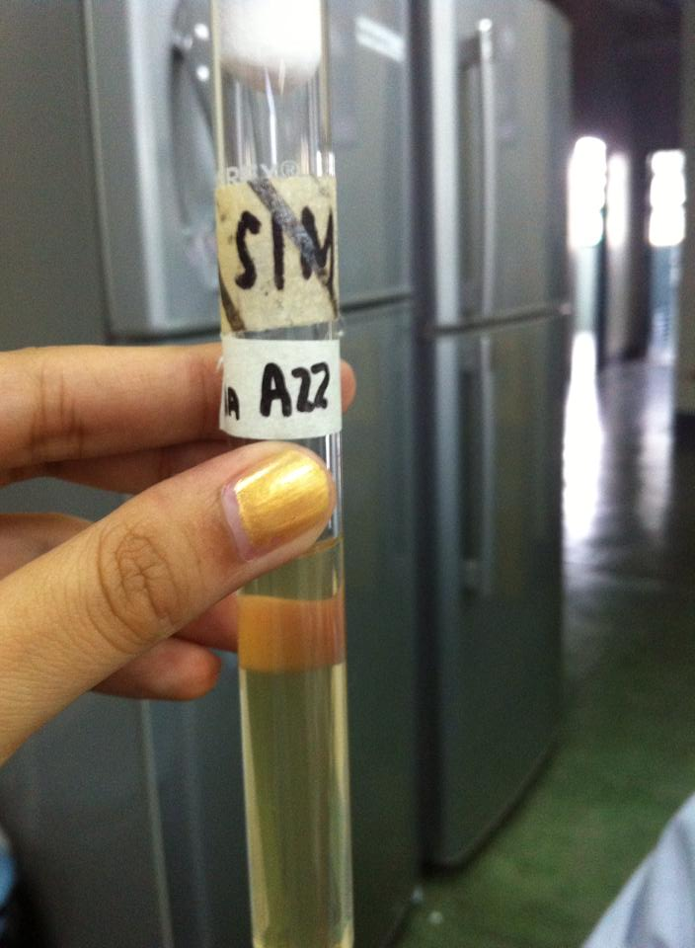

Test: Voges Proskauer
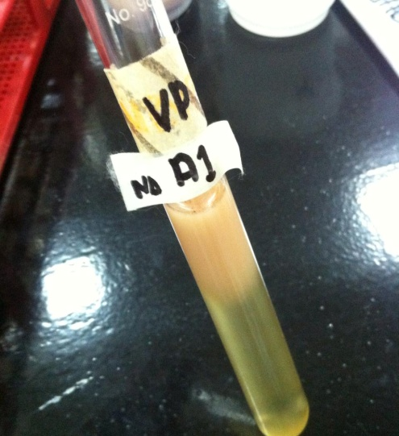
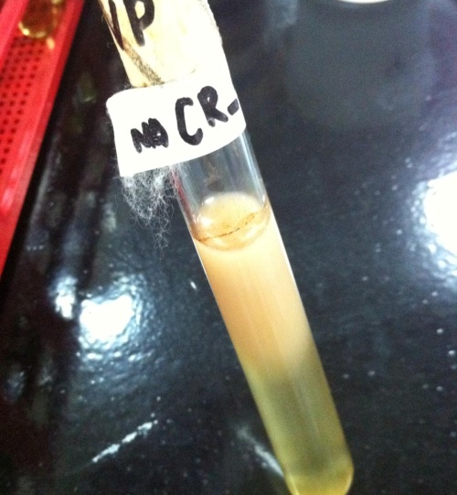
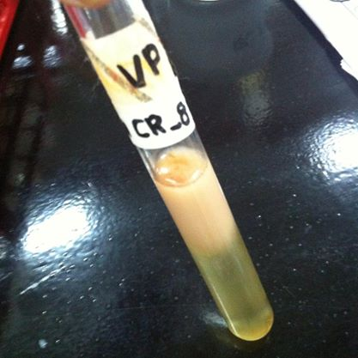

CR-8 CR-9 A-1

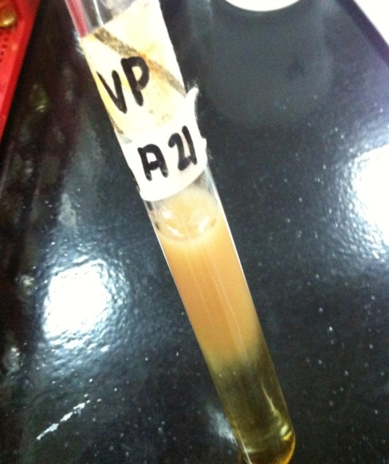
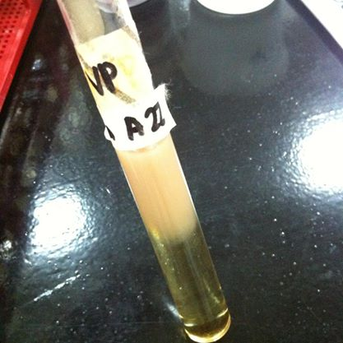

A-21 A-22

Test: Urea

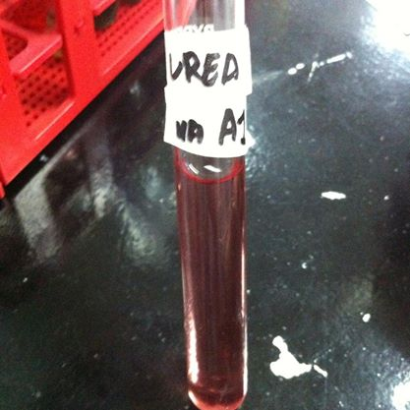
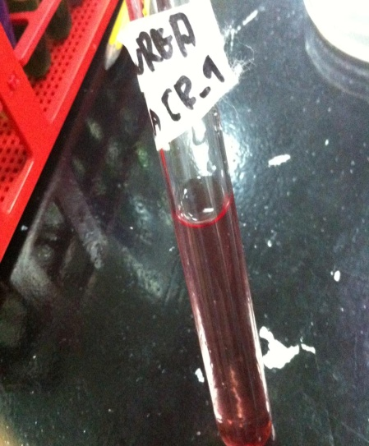
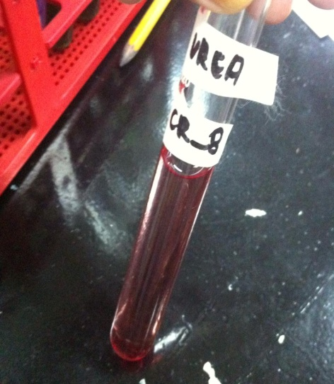

CR-8 CR-9 A-1

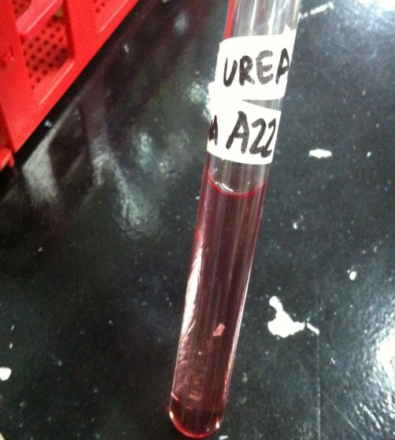
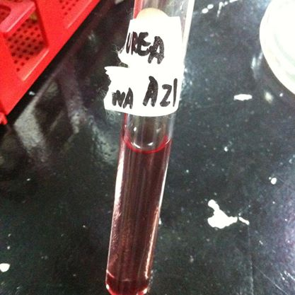

A-21 A-22

Test: Methyl Red

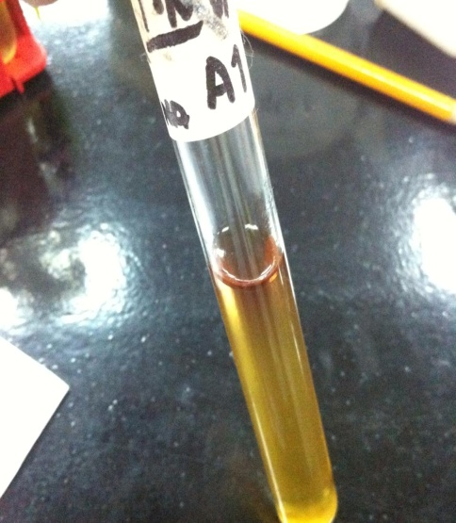
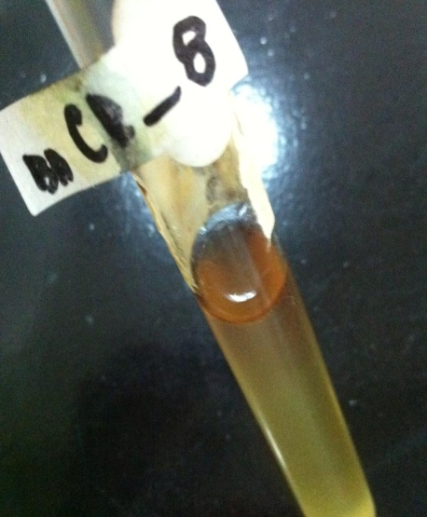
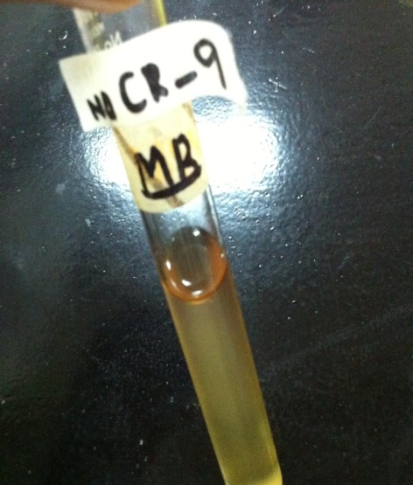

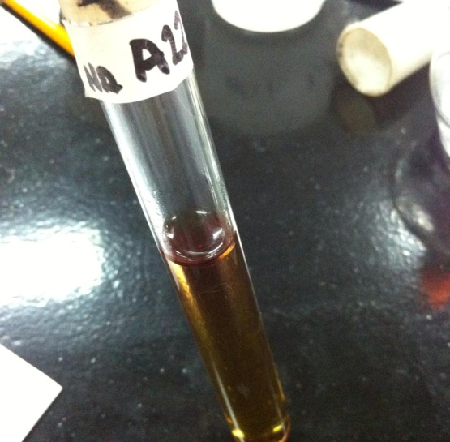
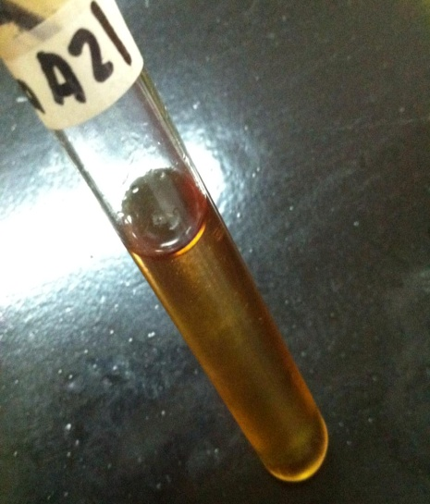

Discussion:
Different tests have been used in this experiment to clearly identify different characteristics of microorganisms using biochemical substances. The different tests will be explained in this chapter.
Simmons Citrate is used for the differentiation of microorganisms on the basis of citrate utilization. The medium contains different substances which help in getting a more reliable data. Like Ammonium Dihydrogen Phosphate which serves as a source of Nitrogen and Sodium Citrate as the source of carbon. Organisms that can utilize Ammonium Dihydrogen Phosphate and Sodium Citrate as their sole sources of nitrogen and carbon will grow on this medium and produce a color change from green (neutral) to blue (alkaline).
Lysine Iron Agar is used for the differentiation of microorganisms on the basis of lysine decarboxylase and hydrogen sulfide production. L-Lysine is the substrate used to detect lysine decarboxylase and lysine deaminase enzymes. Ferric Ammonium Citrate is an indicator of hydrogen sulfide production. And results can be interpreted as positive or negative when reaction produced a purple color (alkaline) butt, purple slant. A negative reaction is yellow (acid) butt, purple (alkaline) slant.
Triple Sugar Iron Agar is used for the differentiation of microorganisms on the basis of dextrose, lactose, and sucrose fermentation and hydrogen sulfide production. Triple Sugar Iron Agar contains three carbohydrates, Dextrose, Lactose and Sucrose. When the carbohydrates are fermented, acid production is detected by the Phenol Red pH indicator. Sodium Thiosulfate is reduced to hydrogen sulfide, and hydrogen sulfide reacts with an iron salt yielding the typical black iron sulfide. Ferric Ammonium Citrate is the hydrogen sulfide (H2S) indicator where results are read: An alkaline slant-acid butt (red/yellow) indicates fermentation of dextrose only. An acid slant-acid butt (yellow/yellow) indicates fermentation of dextrose, lactose and/or sucrose. An alkaline slant-alkaline butt (red/red) indicates dextrose or lactose were not fermented (non-fermenter). Cracks, splits, or bubbles in medium indicate gas production. A black precipitate in butt indicates hydrogen sulfide production.
SIM Medium is used for the differentiation of microorganisms on the basis of hydrogen sulfide production, indole production, and motility. SIM Medium is a semi-solid, due to the low concentration of agar. The semi-solid nature of this medium allows for easy visual determination of motility which appears as growth extending outward from the original line of inoculation.
MR-VP Broth is used for the differentiation of microorganisms on the basis of acid or acetylmethyl carbinol production (MR-VP reaction). In the MR test the pH indicator, methyl red, detects acidic end products.In the VP test, acetoin is oxidized in the presence of oxygen and potassium hydroxide (KOH) to diacetyl, producing a red color. The addition of naphthol before KOH enhances the sensitivity of the test.
Urease Test is a test used to determine ability of microorganisms to degrade urea by means of the enzyme urease.
Answer to Questions:
Test | Procedure | +Result | Interpretation | -Result | Intepretation | +/-
Simmons Citrate | 1. Obtain a pure colony of the test organism.  2. Streak only the surface of the slant with a light inoculum.  3. Incubate tubes at 35 ± 2°C for 18 – 48 hours with loose caps. | A positive reaction is indicated by growth on the slant with an intense blue color (alkaline reaction). | Organism was able to metabolize citrate | A negative reaction is  indicated by inhibition to poor growth without change in color (medium remains green). | Organism wasn’t able to metabolize citrate | POSITIVE  NEGATIVE
Lysine Iron Agar | 1. Inoculate medium by stabbing base of tube butt and streaking slant with a needle.  2. Loosely cap the tube to ensure aerobic conditions. Incubate at 35°C for 18 - 48 hours.  3. Examine at 18 – 24 and 40 – 48 hours for growth and color changes in tube butt and slant, and for  blackening at the apex of slant | A positive lysine decarboxylase reaction is purple (alkaline) butt, purple slant. | An organism is able to decarboxylate lysine | A negative reaction is yellow  (acid) butt, purple (alkaline) slant. | Oraganism wasn’t able tp decarboxylate lysine | POSITIVE  NEGATIVE
Triple Sugar Iron | 1.Sterilize the inoculating needle in the blue flame of the bunsen burner till red hot and then allowed to cool. 2. From the rack, take the Trypticase soy broth tube containing the 24-48 hour culture, remove the cap and flame the neck of the tube. 3.Using aseptic technique, take the culture of the organism from the TSB (tryptic soy broth) tube with the needle. 4.Again flame the neck of the tube and replace the tube in the test tube rack. 5. Take a sterile TSI slant tube from the rack, remove the cap and flame the neck of the tube. 6.Stab the needle containing the pure culture into the medium, upto the butt of the TSI tube, and then streak the needle back and forth along the surface of the slant. 8.Again flame the neck of the TSI tube, cap it and place it in the test tube rack.Incubate at 37ºc for 18 to 24 hours. | An acid slant-acid butt  (yellow/yellow) | fermentation of dextrose, lactose and/or sucrose | . An alkaline slant-alkaline butt  (red/red) | dextrose or lactose were not fermented (non-fermenter) | POSITIVE  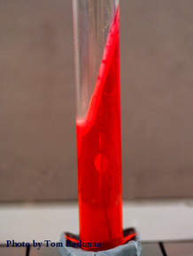  NEGATIVE
SIM MEDIUM | 1. Using a wire, inoculate test organism two-thirds into the medium with stab motion.  2. Incubate with loose caps at 35 ± 2°C for 18 – 24 hours.  3. Examine tubes after incubation for motility and H2S production.  4. Add 3 – 4 drops of Kovac’s Reagent to each tube. Record as indole positive if a pink or red color appear,  or as indole negative if there is no color change. Add Kovac’s Reagent after determining motility and H2S  production. | 1.turbidity of the medium or growth extending from inoculating stab line  2. a blackening along the stab line | Motility  H2S Production | No turbidity of the medium or growth extending from inoculating stab line | No Motility | POSITIVE  NEGATIVE
MR-VP | Inoculate MR-VP Broth with growth from a single colony. Incubate at 35 ± 2°C for 48 hours. Proceed with  Methyl Red or Voges-Proskauer test. | Methyl Red (MR) Test: Positive – bright red color  Voges-Proskauer (VP) Test: Positive – red color | detects acidic end products  Acetoin is oxidized | Methyl Red (MR) Test: yellow- orange color.  Voges-Proskauer (VP) Test: – no red color | No Detection of acidic end products  No oxidation of acetoin | MR: POSITIVE  MR: NEGATIVE  VP: POSITIVE  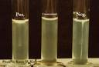  VP: NEGATIVE
Urease Test | Streak the surface of a urea agar slant with a portion of well isolated colony. Alternatively, slant can be incubated with 1-2 drops of overnight brain-heart infusion broth.  Leave the cap on loosely and incubate the test tube at 35 in ambient air for 48 hours to 7 days.  If organism produces urease enzyme, the color of the slant changes from light orange to magenta. If organism do not produce urease the agar slant and butt remain light orange (No color change). | Bright pink | Organism has an ability to produce exoenzyme | Yellow coloration | Organism wasn’t able to produce exoenzyme | 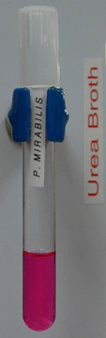  POSITIVE  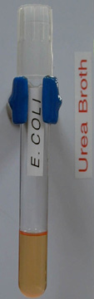  NEGATIVE

2. BIOCHEMICAL PROPERTIES OF:
Microorganism | SC | TSI | LIA | SIM | MR | VP | UREA
E.Coli | - | + | + | + | + | - | -
S. Aureus | + | Acid ferment | + | - | + | + | +
B.Subtilis | + | - | + | - | - | + | +
N. Gonorrhea | + | - | - | - | + | - | -

3. Staphylococcus Bacteria

Conclusion and recommendations:
I therefore conclude that with the help of biochemical tests a more specific result of an identification of bacteria can be obtained. Based from the experiments, a staphylococcus bacteria was the bacteria presented and was cultured by our group.

References:
http://microbeonline.com/urease-test-principle-procedure-interpretation-and-urease-positive-organsims/
http://www.neogen.com/Acumedia/pdf/ProdInfo/7156_PI.pdf
http://www.neogen.com/Acumedia/pdf/ProdInfo/7211_PI.pdf
http://www.neogen.com/Acumedia/pdf/ProdInfo/7162_PI.pdf
http://www.neogen.com/Acumedia/pdf/ProdInfo/7221_PI.pdf
http://www.neogen.com/Acumedia/pdf/ProdInfo/7237_PI.pdf
http://amrita.vlab.co.in/?sub=3&brch=76&sim=216&cnt=2

