Group 5:
- Quilang, Aleia Sharisse F.
- Quinto, Thea Marie Dolores N.
- Recio, Jose Angelo G.
- Refuerzo, Jirah Angelica M.
- Robles, AndreuVinzent F.
- Rodriguez, Joanne Claire E.
- Romero, Mavourneen Tracy Chanel V.
- Samonte, Muriel Fay D.

Objectives:
To know the different agars
To know how to make agars and differentiate those.

INTRODUCTION
Microrganisms need nutrients, a source of energy and certain environmental conditions in order to grow and reproduce. In the environment, microbes have adapted to the habitats most suitable for their needs, in the laboratory, however, these requirements must be met by a culture medium. This is basically an aqueous solution to which all the necessary nutrients have been added. Depending on the type and combination of nutrients, different categories of media can be made.
Complex media are rich in nutrients, they contain water soluble extracts of plant or animal tissue (e.g., enzymatically digested animal proteins such as peptone and tryptone). Usually a sugar, often glucose is added to serve as the main carbon and energy source. The combination of extracts and sugar creates a medium which is rich in minerals and organic nutrients, but since the exact composition is unknown, the medium is called complex.
Defined media are media composed of pure ingredients in carefully measured concentrations dissolved in double distilled water i.e., the exact chemical composition of the medium is known. Typically, they contain a simple sugar as the carbon and energy source, an inorganic nitrogen source, various mineral salts and if necessary growth factors (purified amino acids, vitamins, purines and pyrimidines).
Selective/differential media are media based on either of the two categories above supplemented with growth-promoting or growth-inhibiting additives. The additives may be species- or organism-selective (e.g., a specific substrate, or an inhibitor such as cyclohexamide (artidione) which inhibits all eucaryotic growth and is typically used to prevent fungal growth in mixed cultures).

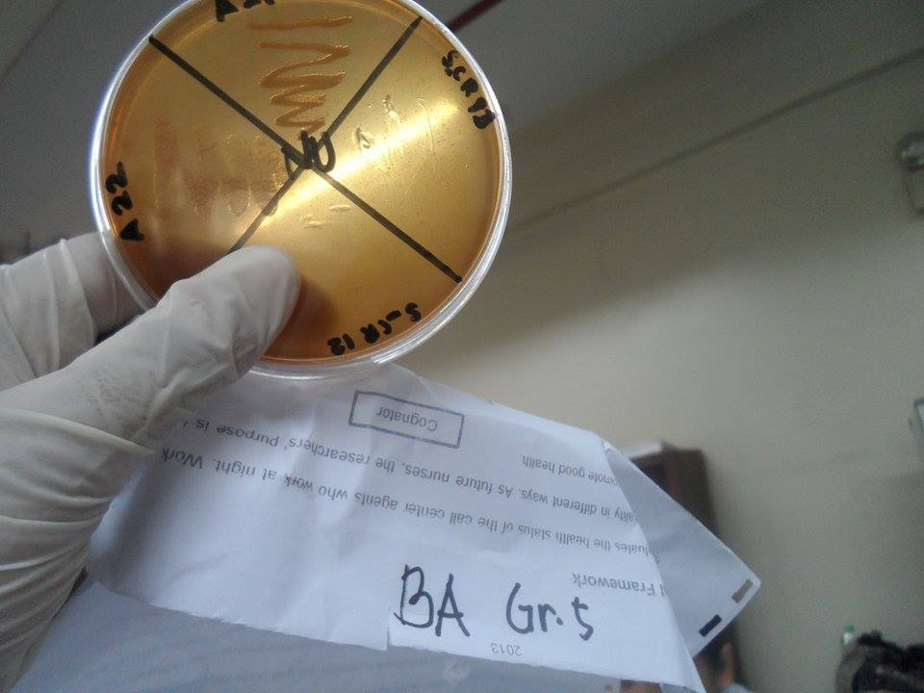
DISCUSSION:

Blood agar is actually a couple of related media, all of which are rich formulations containing peptones, yeast extracts, liver or heart extracts (depending on the medium), and blood. The blood is usually sheep's red blood cells (RBC), though horses and other species may be used. Blood agar is used to grow fastidious organisms (species that do not grow easily) requiring a rich media providing many nutrients and growth factors that are largely supplied by blood. It is also a differential media in allowing the detection of hemolysis (destroying the RBC) by cytolytic toxins secreted by some bacteria, such as certain strains of Bacillus, Streptococcus, Enterococcus, Staphylococcus, and Aerococcus.
Blood agar plates are routinely used in the clinic to test for pathenogenic bacteria in throat swabs. These throat pathogens are often Gram positive cocci that may be hemolytic, producing exotoxins called hemolysins that destroy blood cells. One such pathogen that BAP can detect is Streptococcus pyogenes which causes a number of diseases including strep throat, rheumatic fever, and necrotizing fascitis.
Purpose: blood agar plates allow for the growth of fastidious organisms and the differentiation of three hemolytic activities.
The Three Types of Lytic Activity
- clear zone around bacterial growth -RBC hemolyzed completely (Beta-hemolysis, pathogenic)
- green zone around growth -RBC partially hemolyzed (Alpha-hemolysis)
- no change around growth -RBC is not hemolyzed (Gamma-hemolysis or no hemolysis)

MacConkey Agar is a selective and differential culture media commonly used for the isolation of enteric Gram-negative bacteria. It is based on the bile salt-neutral red-lactose agar of MacConkey.
Crystal violet and bile salts in incorporated in MacConkey Agar to prevent the growth of gram-positive bacteria and fastidious gram-negative bacteria, such as Neisseria and Pasteurella. Gram-negative enteric bacteria can tolerate to bile salt because of their bile-resistant outer membrane.

MacConkey Agar is selective for Gram negative organisms, and helps to differentiate lactose fermenting gram negative rods from Non lactose fermenting gram negative rods. It is primarily used for detection and isolation of members of family enterobacteriaceae andPseudomonas spp.
Composition of MacConeky Agar:
- Enzymatic Digest of Gelatin, Casein and Animal tissue: provides nitrogen, vitamins, minerals and amino acids essential for growth.
- Lactose: fermentable carbohydrate providing carbon and energy.
- Bile Salts: selective agents and inhibit Gram positive organisms.
- Crystal Violet: Use: Gram positive bacteria are generally inhibited by crystal violet.
- Sodium Chloride: supplies essential electrolytes for transport and osmotic balance.
- Neutral Red: pH indicator. which is red in color at pH’s below 6.8.
When lactose is fermented, the pH of the medium decreases, changing the color of neutral red to pink
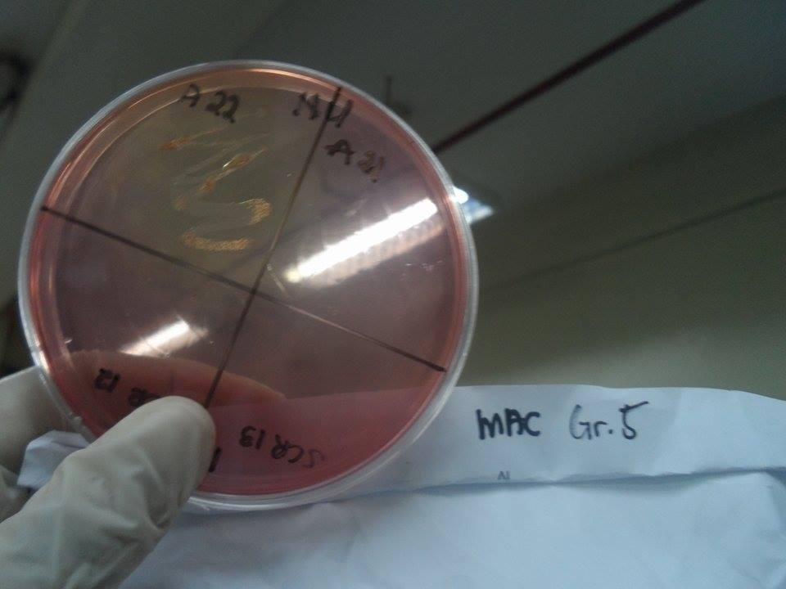
- Agar : Solidifying agent

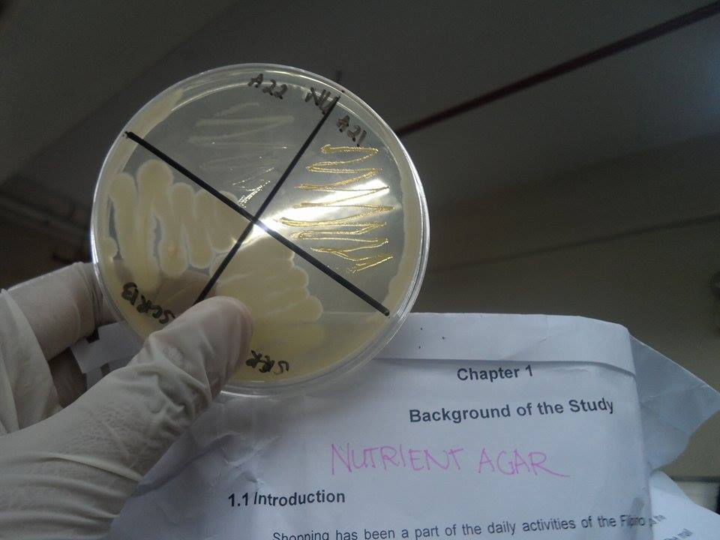
Nutrient agar is a general-purpose, nutrient medium used for the cultivation of microbes. It is frequently used for isolation and purification of cultures. As we are using it here, it can also be used as a means for producing the bacterial lawns needed for antibiotic sensitivity tests. In actuality, antibiotic sensitivity testing is typically performed on media specially formulated for that purpose.

Nutrient agar consists of heat-stable digestive products of proteins (called peptones) and beef extract. Both of these provide amino acids, minerals, and other nutrients used by a wide variety of bacteria for growth. In addition, it contains agar as a solidifying agent.
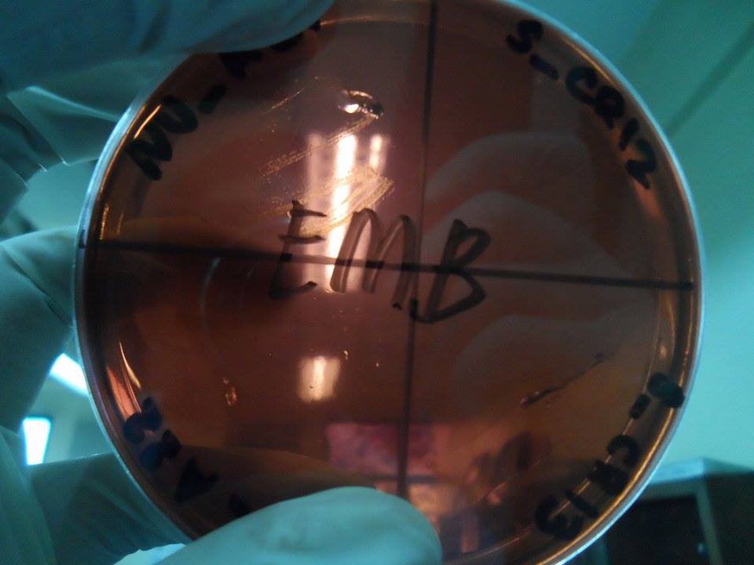

Eosin Methylene Blue Agar
Eosin methylene blue agar (EMB) is a selective and differential medium used to isolate fecal coliforms. Eosin Y and methylene blue are pH indicator dyes which combine to form a dark purple precipitate at low pH; they also serve to inhibit the growth of most Gram positive organisms. Sucrose and lactose serve as fermentable carbohydrate sources which encourage the growth of fecal coliforms and provide a means of differentiating them.
Vigorous fermenters of lactose or sucrose will produce quantities of acid sufficient to form the dark purple dye complex. The growth of these organisms will appear dark purple to black. Escherichia coli, a vigorous fermenter, often produces a green metallic sheen. Slow or weak fermenters will produce mucoid pink colonies. Normally-colored or colorless colonies indicate that the organism ferments neither lactose nor sucrose and is not a fecal coliform.

Chocolate Agar is the lysed blood agar. The name is itself derived from the fact that Red blood cell lysis gives the medium a chocolate-brown color
The composition of Chocolate agar and the Blood Agar is same and the only difference is while preparing Chocolate agar, the red blood cells are lysed.
The lysis of RBC releases intracellular nutrients such as hemoglobin, hemin (Factor X) and the coenzyme Nicotinamide adenine dinucleotide (NAD or V Factor) in to the agar for utilization by fastidious bacteria.
The most common species that require this enriched medium for growth include: Neisseria gonorrhoeae and Haemophilus spp. Neither of these species is able to grow on Sheep Blood Agar.
Colony characteristics in chocolate agar
- Neisseria meningitidis: Growth on chocolate agar is grayish, non-hemolytic, round, convex, smooth, moist, glistening colonies with a clearly defined edge.
- Neisseria gonorrhoeae: Colonies on GC-Chocolate agar are pinkish-brown and translucent, exhibit smooth consistency and defined margins, and are typically 0.5-1 mm in diameter.
- Haemophilus influenzae: Non hemolytic, opaque cream-to-gray colonies (Accompanying Sheep blood agar shows no growth)

PHYSICAL STATE
- Liquid Media: these are water-based solutions that do not solidify at temperatures above freezing point. These media are commonly termed broths, milk or infusion.
- Semisolid Media: these exhibit a clotlike consistency at ordinary room temperature. These media contain an amount of solidifying agent (agar or gelatin) which thickens them but does not produce a firm substance.
- Solid Media: these provide a firm surface on which cells can form discrete colonies and are advantageous for culturing and isolating bacteria and fungi. Solid media come in two forms: liquefiable or reversible solid media and nonliquefiable or non-reversible solid media.
CHEMICAL COMPOSITION
- Synthetic: these compositions are chemically defined. Synthetic media are composed of pure organic and inorganic compounds which have molecular contents specified by means of an exact formula.
- Non-synthetic: these complex media contain at least on ingredient that is not chemically defined, not a simple compound, pure compound and not representable by an exact chemical formula. Most of these substances are extracts of animals, plants, or yeasts.

Questions

what are the difficulties of preparing culture media?
Light
All prepared culture media and their components should be stored away from light and exposure to direct sunlight should be avoided at all times.
Humidity
Sealed glass and plastic containers are unaffected by normal laboratory humidity. Opened containers of dehydrated powders will be affected by high humidity. Hot, steamy media preparation rooms are not suitable environments to store containers of culture media; particularly containers which are frequently opened and closed. An adjacent cold room or an adequate storage cupboard are preferable storage areas.
Temperature and time
The temperature storage conditions of culture media and their components vary widely. The following product groupings will help to differentiate the various requirements.
Culture Media: Sealed, unopened containers should be stored at room temperature 15-20°C. Opened containers should have the cap or lid carefully and securely replaced. It is important that opened containers are stored in a dry atmosphere at room temperature. Shelf life 1 to 5 years.
Prepared Broth Media: Store at 2-8°C. Do not allow the products to freeze. Shelf life 6 months to 2 years.
Prepared Plates of Culture Media: Poured plates of agar media are especially vulnerable to infection, dehydration and chemical degradation. Aseptic preparation and storage are essential to protect plates from microbial infection. Water losses on storage can be minimised by impermeable wrapping and/or storage at 2-8°C. Chemical degradation e.g. oxidation or antimicrobial loss, can be retarded by protection from light, heat and dehydration.
It is important, however, to monitor the storage of prepared plates by quality control tests so that any deterioration can be detected and the storage period accurately determined. Simple weighing tests of fresh and stored plates will determine the rate of moisture loss. Weight loss greater than 5% will indicate a significant loss of water.
Gas Generating Kits: Store at 2-8°C in a dry place. Do not store these kits at a higher temperature for long periods. Shelf life 3 years.
Sterile Reagents: Store at 2-8°C, except Horse Serum store at -20 to +8°C.
Susceptibility Discs: Store at -20°C but keep working stock at 2-8°C. Shelf life 1 to 2 years.
Preparation of dehydrated media
Dehydrated media are hygroscopic and are sensitive to moisture, heat and light. They are adversely affected by drastic changes in temperature e.g. hot/cold cycling temperatures which may occur between day and night laboratory temperatures in winter.
Storage conditions are usually indicated on the product label and should be followed.
1 Write on the label the date of receipt in the laboratory.
2 Store as indicated on the label; usually below 25°C in a dry area, away from direct sunlight, autoclaves, drying ovens or other heat sources.
3 Check expiry date on the label, some media have significantly shorter shelf-lives than others.
4 Use stock in lot/batch number order. Do not open a new bottle until the previous bottle has been emptied. Note on the label the date the container is first opened. After use, make sure the container is tightly closed and return it to the designated storage area.
5 Order the medium in an appropriate size of container and in a quantity which accords to normal use requirements. A medium in a large container which has been opened many times will deteriorate on storage. Discard the medium if the powder is not free flowing, if the colour has changed or if it appears abnormal in any way.

What are the different ways of doing inoculations and streaking

II. Streaking and Innoculating Plates
Cultures ordered from a supply company or stock center will probably not consist of genetically identical bacteria. The bacteria will all be of the same species, and available as a single strain. However, random mutations may still exist due to the large number of bacteria present. To obtain a source of genetically identical bacteria, streak plates are used. Streaking a plate allows the bacteria to be spread out so that a single bacterium can be isolated from all other bacteria. This technique is called streaking for individual colonies. Since bacteria are so small, you will not be able to see that isolated bacterium. However, that bacterium will reproduce itself by binary fission (typical division time is on the order of 20 minutes), resulting in bacteria which are genetically identical to the original bacterium and to each other. These bacteria are visible as a small round colony growing where there had been one isolated bacterium. This method allows you to use the individual colony repeatedly and expect similar results.
There are several acceptable streak plate methods. The method described here is called the "T'' streak and is one of the easiest.
1. Light a Bunsen burner in your bench space. To maintain sterile conditions, inoculation should occur within 20 cm of the flame. Wait 20 seconds before opening the petri dish and inoculating. This gives the flame time to sterilize the local air. Remember that you want to achieve sterile conditions. Do not work with the plate close to your face. This will violate the sterile environment.
2. Use a marker or wax pencil to draw a T on the bottom of a plate of nutrient agar. This divides the plate into three sections (Figure . One section covers one half the plate. The other half is divided into two quarters.
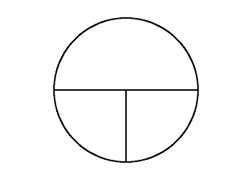
Figure 5.2: Draw a "T'' on the bottom of your petri dish as shown.
3. Sterilize the inoculating loop (Figure ), by holding its tip in the flame until it turns red.
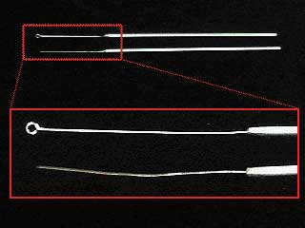
Figure 5.3: Wire innoculating loop and needle used in this experiment.
4. Lift up the lid of the plate you will be inoculating and poke the inoculating loop through the agar close to the side of the petri dish to cool it. This prevents the heat from killing the bacteria sample you want to use. The heat will not harm the agar. Try to lift the lid of the plate up only as much as is necessary to put the loop inside. If you completely remove the lid, it can become contaminated with bacteria from the environment.
5. Touch the loop to the edge of the colony growing on the plate. Then take the loop and place the lid securely back on the plate.
6. Set the plate you will be streaking so that its bottom is sitting on the bench top and you can see the T clearly. The largest section should be at the top. Carefully lift up the lid and touch the inoculating loop to the upper left hand corner of the largest section of the plate. Move the loop from left to right, back and forth, across the surface of the agar. See Figure . Since nutrient agar is a gel with properties similar to Jell-O, do not push down with the loop or you will gouge the agar.
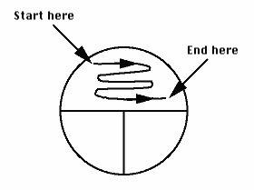
Figure 5.4: Touch the inoculating loop to the upper left hand corner and then move it across the agar from left to right as shown.
7. Replace the lid of the petri dish and flame the loop again to kill any remaining bacteria on it. Rotate the plate 90 degrees counterclockwise. Carefully lift the lid slightly and touch the loop into the left side of the plate which contains the area you streaked in the previous step. Move the loop across the surface of the agar until it is in the smaller section in the upper right of the plate. Within that quarter of the plate, move the loop back and forth across the agar surface (Figure ).
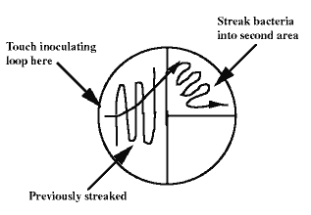
Figure 5.5: Touch the loop to the area previously streaked and then move the loop across the agar as shown.
8. Repeat Step 7 as shown in Figure .
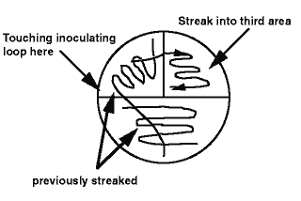
Figure 5.6: Touch the loop on the previously streaked area. Then move the loop across the agar onto the third area as shown.
9. Replace the lid of the petri dish and flame the loop again to kill any remaining bacteria on it.
10. Seal the petri dish with a layer of parafilm around the edge. This keeps the agar from drying out while it is in the incubator. Incubate the streak plate at 37�C until you can see individual colonies. Make sure to keep an open beaker of water in the incubator. Periodically check that the beaker has water in it-do not let it run dry. The water will maintain a constant level of humidity (100%) in the incubator. See Figure .
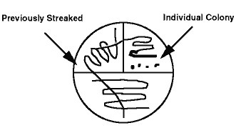
Figure 5.7: Incubate the streak plate until you can see individual colonies. Make sure to keep an open beaker of water in the incubator.
Once you have a streak plate with individual colonies, you should inoculate, from an individual colony, nutrient agar plates containing various concentrations of nutrients.
1. As in plate streaking, light a Bunsen burner in your bench space and work within 20 cm of the flame to maintain sterile conditions. Again, wait 20 seconds before opening the petri dish and inoculating.
2. Use a marker or wax pencil to place a dot in the center of the outside bottom of the petri dish of nutrient agar. Now turn the plate over so that the bottom is sitting on the bench top. Notice that you can see the dot you just made through the agar. This will help you place the bacteria on the surface of the nutrient agar's center.
3. Sterilize the inoculating needle by placing the tip of the needle in the flame. Keep the tip there until the metal turns red.
4. Choose a streak plate containing an individual colony. Lift up the lid of the streak plate you will be inoculating from, and poke the inoculating needle into the agar close to the side of the plate to cool it. This prevents the heat from killing the bacteria sample you want to use. The heat will not harm the agar. Lift the lid of the plate up only as much as is necessary to put the needle inside. If you completely remove the lid, it may become contaminated with bacteria from the environment.
5. Touch the inoculating needle to an individual colony growing on the plate. Take care not to stab the inoculating needle down into the agar. Then remove the inoculating needle from the plate and place the lid securely back on the plate.
6. Carefully lift up the lid of the plate you are inoculating onto. Touch the inoculating needle to the very center of the surface of the nutrient agar. The dot you drew on the bottom should make it easier to locate. Be careful that you do not stab the inoculating needle into the nutrient agar.
7. Place the lid on the plate, and flame the inoculating needle to kill any remaining bacteria.
8. Seal the plate with a layer of parafilm around the edges. This keeps the nutrient agar from drying out while it is in the incubator. Make sure to keep an open beaker of water in the incubator. Periodically check that the beaker has water in it - do not let it run dry. The water will maintain a constant level of humidity (100%) in the incubator.

References

http://www.sigmaaldrich.com/analytical-chromatography/microbiology/learning-center/theory/media-preparation.html
http://www.vumicro.com/vumie/help/VUMICRO/Nutrient_Agar_Plate.htm
http://www.austincc.edu/microbugz/eosin_methylene_blue_agar.php
http://microbeonline.com/chocolate-agar-composition-uses-colony-characteristics/
http://spot.pcc.edu/~jvolpe/b/bi234/lab/differentialMedia/bloodAgarPlates.htm
http://microbeonline.com/macconkey-agar-mac-composition-preparation-uses-and-colony-characteristics/
http://polymer.bu.edu/ogaf/html/chp51exp2.htm

