4A: Handwashing
Members:
Aleia Sharisse Quilang
Thea Marie Quinto
Jose Angelo Recio
Jirah Angelica Refuerzo
Andreu Robles
Joanne Claire Rodriguez
Mavourneen Tracy Chanel Romero
Muriel Fay Samonte

Introduction:
Hand washing for hand hygiene is an effective way to prevent the spread of infections and chemicals which can cause harm or disease. Microbes like bacteria and viruses can spread through physical contact especially touch. Regular hand washing, before and after certain activities, is one of the best ways to remove germs, avoid getting sick, and prevent the spread of germs to others.

Objectives:
- To inform the reader about the importance of hand washing.
- To familiarize ourselves with proper hand washing techniques.
- To inform the reader about other mediums used for hand washing.

Results:
- The effectiveness of the use of Oregano and Dalanghita in hand washing
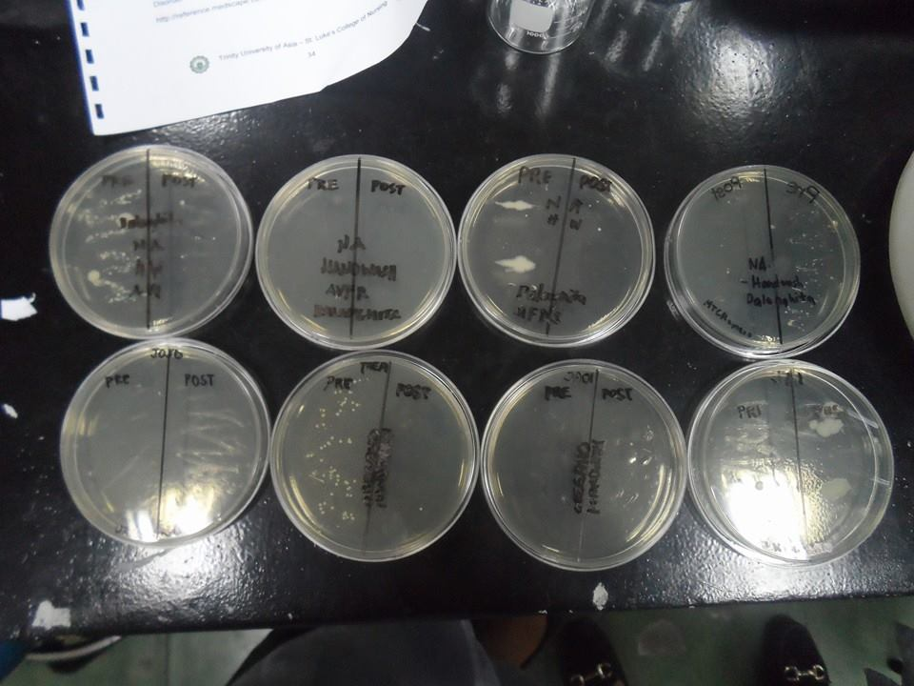
Dalanghita
Name | Pre | Post
Aleia Quilang | Appearance of medium and large colonies. | Effective, only a few small colonies were present.
Andreu Robles | No colonies present. | Effective, no colonies present.
Muriel Fay Samonte | Appearance of few large colonies. | Effective, only a few small colonies were present.
Tracy Romero | Appearance of small and medium colonies. | Effective, only a few small colonies were present.

Oregano
Name | Pre | Post
Joanne Rodriguez | Appearance of few small colonies. | Effective, no colonies present.
Thea Marie Quinto | Appearance of small colonies. | Effective, no colonies present.
Jose Angelo Recio | No colonies present. | Effective, no colonies present.
Jirah Refuerzo | Appearance of large colonies. | Effective, only a few large colonies were present.

Discussion:
Group 5 used two different mediums in hand washing. One is the use of oregano and the other is the use of dalanghita (tangerine).
Researchers conducted a similar investigation about the potential use of oregano essential oil as an antimicrobial agent in liquid soap for hand washing and for food contact surface cleaning. Oregano essential oil (O.E.O.) was emulsified in liquid detergent solution. This was challenge tested against a commercial antimicrobial soap in hand washing trials using natural flora. Soap with O.E.O. was as effective as the commercial antimicrobial soap at reducing aerobic plate count on the hands, and more effective than plain soap with no additives. Cloths wetted with soap with O.E.O. were used to clean three different surfaces contaminated with four bacterial pathogens. For three of the four pathogens, the addition of 0.5% v/v O.E.O. to the soap solution enhanced cleaning performance and also reduced bacterial survival on the cloth after cleaning.
Dalanghita (tangerine or mandarine orange) is a small citrus tree with fruit resembling other oranges. In traditional Chinese medicine, the dried peel of the fruit is used in the regulation of ch'i, and also used to treat abdominal distension, to enhance digestion, and to reduce phlegm. Dalanghita is considered a Volatile Oil / Antibacterial according to conducted researches. Volatile oil showed antibacterial and antifungal activities against pathogenic microbial strains: E. coli. S. aureus, Aspergillus flavus, A. niger, A. fumigatus and Candida albicans under in vitro condition.
Answer to Questions:
- What is the correct step by step procedure of hand washing?
- Wet hands with water
- Apply enough soap and hand wash to cover all hand surfaces
- Rub hands palm to palm
- Right palm over the other hand with interlaced fingers and vice versa
- Palm to palm with fingers interlaced
- Backs of fingers to opposing palms with fingers interlocked
- Rotational rubbing of left thumb clasped in right palm and vice versa
- Rotational rubbing, backwards and forwards with clasped fingers of right hand in left palm and vice versa
- Rinse hands with water
- Dry thoroughly with towel. Duration of procedure: At least 15 seconds

- Are sanitizers/alcogels good alternatives to using soap?
- If soap and water are not available, use an alcohol-based hand sanitizer that contains at least 60% alcohol. Alcohol-based hand sanitizers can quickly reduce the number of microbes on hands in some situations, but sanitizers do not eliminate all types of germs. Hand sanitizers may not be as effective when hands are visibly dirty or greasy.

- What is the difference between soaps and detergents?
Soaps
1. Soap are made from fat and alkali by specification method
2. There are cheap.
3. There are not suitable for delicate clothes.
4. They are clean better in hot water.
5. They don't produce lather with hard water and are not able to clean the cloth.
6. Lot of water is needed to remove soap from the cloth.
Detergents
1. Detergents are carbonic compounds which are not alkaline.
2. They are costly.
3. They are suitable for delicate clothes.
4. They clean both in hot and cold water.
5. They clean the cloth even in hard water.
6. They are removed very easily so less quantity of water is needed.
- Do you think that using a brush or similar implements in hand washing is usual? Explain.
- No, the use of brush or similar implements is not usual during a routine hand washing because the use of brushes and its similar implements are only used during surgical aseptic techniques.
- What is the importance of hand washing in prevention of disease transmission? Explain.
- Hand washing decreases the chances of disease transmission. Clean hands can stop germs from spreading from one person to another and throughout an entire community.
Conclusion and Recommendation:
- The results of the experiment clearly showed the effectiveness of oregano and dalanghita as a substitute for soap in hand washing. After hand washing, the two mediums showed a significant decrease of bacteria but as a comparison, oregano has showed better results in decreasing the number of microbes or colonies present. We therefore conclude that oregano is an effective hand wash substitute for soap.
References:
http://www.researchgate.net/publication/249316595_Oregano_essential_oil_as_an_antimicrobial_additive_to_detergent_for_hand_washing_and_food_contact_surface_cleaning
http://stuartxchange.com/Dalanghita.html
http://www.wash-hands.com/hand_hygiene_and_you/how_to_wash_your_hands
http://www.cdc.gov/features/handwashing/
http://www.britannica.com/EBchecked/topic/550751/soap-and-detergent
http://www.cleaninginstitute.org/clean_living/soaps__detergents_chemistry.aspx

