EXERCISE 3B: Morphological Characteristics

Group 5:
Quilang, AlieaSharisse F.
Quinto, Thea Marie Dolores N.
Recio, Jose Angelo G.
Refuerzo, Jirah Angelica M.
Robles, AndreuVinzent F.
Rodriguez, Joanne Claire E.
Romero, Mavourneen Tracy Chanel V.
Samonte, Muriel Fay D.

INTRODUCTION
Bacteria are characterized by the presence or absence of a number of different structures. Endospores, capsules and flagella are three such examples. Each of these structures is visible with light microscopy if the correct staining procedure is employed.
ENDOSPORES are survival structures. In poor growth conditions some genera may sporulate. Rather than dying, endospores survive in a dormant state. Endospores are unique to Bacteria and are formed by a limited number of bacterial genera. The soil bacteria within the genera Bacillus and Clostridium are the most familiar
CAPSULES are slippery structures found exterior to the cell wall of many bacteria. Capsules may be involved in bacterial virulence (cells with capsules are less likely to be phagocytized), or in bacterial adherence (such as the adherence of Streptococcus mutants to teeth). Capsules are normally composed of polymers of sugars and/or proteins. They have no net charge and will not bind charged dye particles.

OBJECTIVES:
- To learn the role of the bacterial structures: endospore, capsule, and flagella.
- To learn to recognize endospores and complete the Endospore Stain effectively.
- To learn to recognize bacteria with capsules and complete the Capsule Stain effectively.
- To learn to recognize motile bacteria in a wet mount and in a motility stab.
To learn the motility stab protocol.
- To learn how recognition of bacterial structures are used in bacterial classification
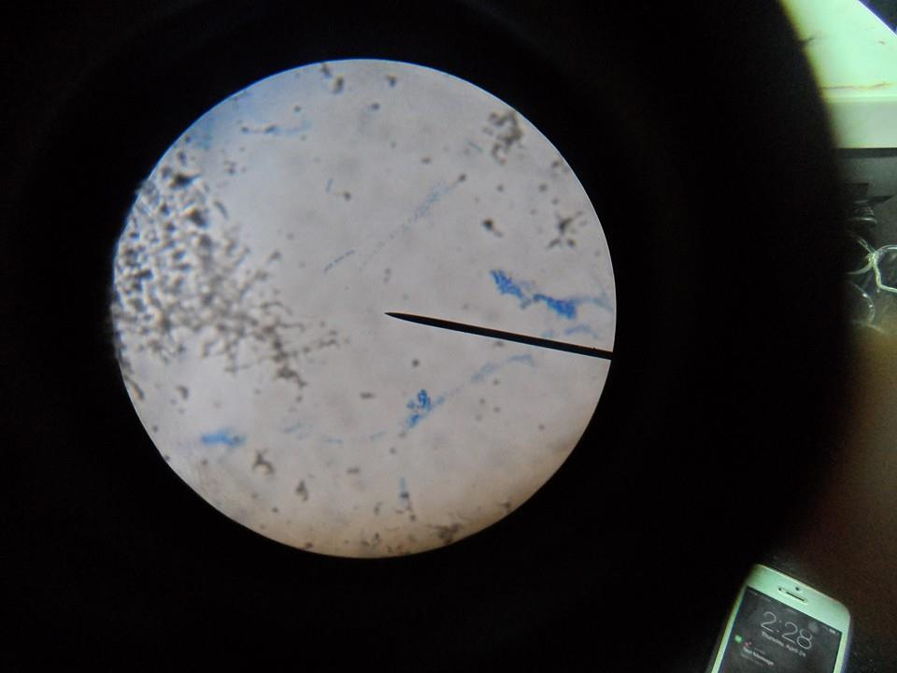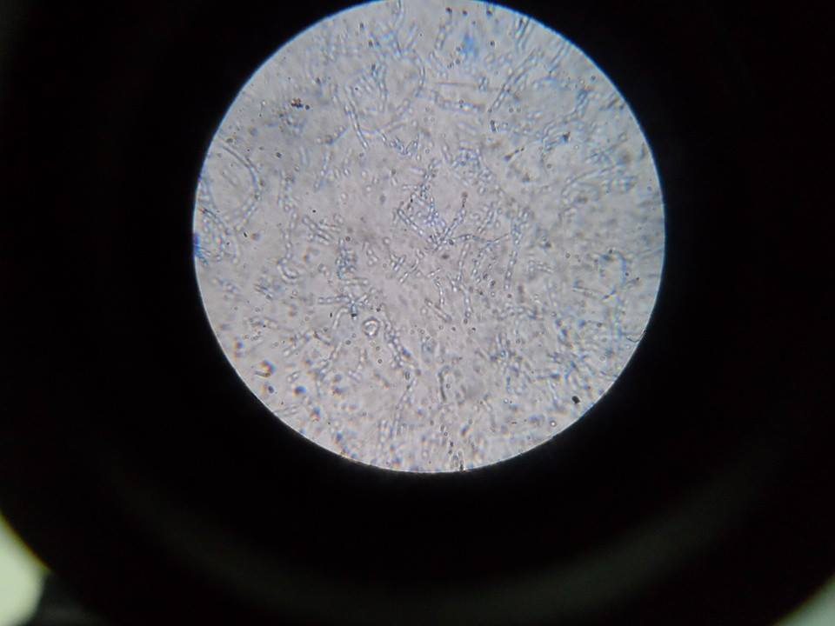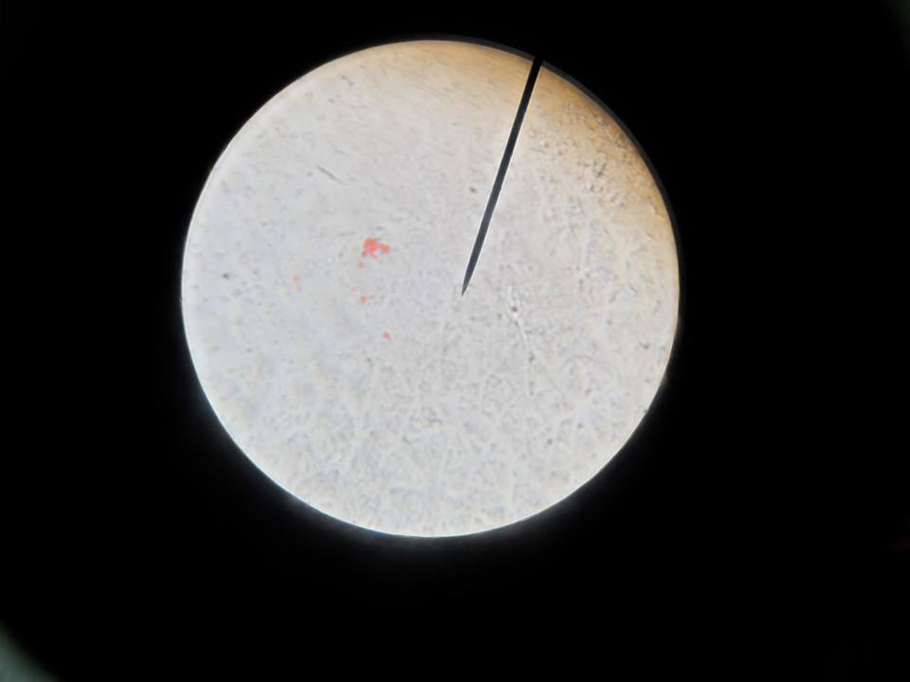
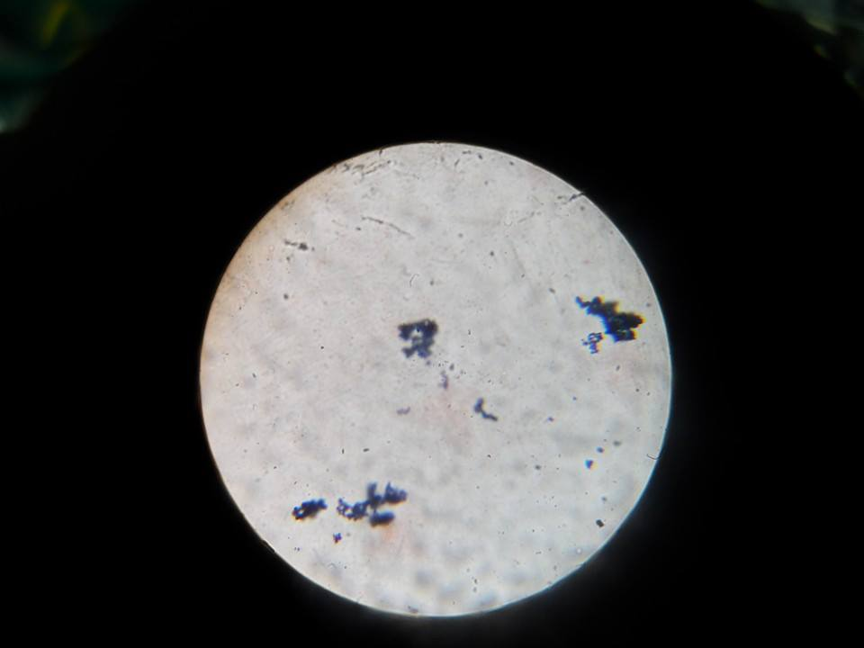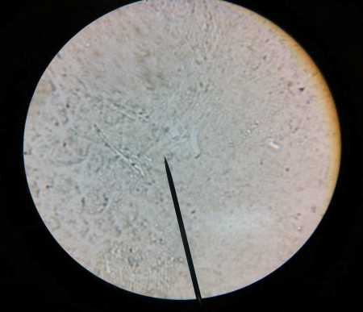

DISCUSSION

 | Size | Form | Edge/Margin | Elevation | Surface | Color | Test tubes
A22 (NA) | Pin point | Circular | Undulate | Flat | Rough | White | No growth of any substance
A21 (NA) | Pin point | Circular | Undulate | Flat | Rough | White | Growth of white substance at the bottom
SCR9 (NA) | Large | Irregular | Entire | Raised | Smooth | White | No growth at the bottom
SCR8 (BA) | Large | Irregular | Entire | Raised | Smooth | Yellowish | Growth of white substance/precipitate
A1 (BA) | Large | Irregular | Entire | Raised | Smooth | White | White precipitate

Answer to Questions

- What should we use to identify the indirect method of testing for motility?
- By the use of motility stab. A motility stab contains growth media and low percentage of agar in a test tube.
- What are the morphological terms?
- morphological terms such as granular, arborescent, wavy interlaced, and filamentous” and elevation, edge, color, and texture were used.
- What are the methods the used for General and Molecular Bacteriology?
- the terms were categorized by descriptions of color, form, elevation, margin, opacity, and texture
- What are the tool used in observing the colony morphology?
- used by clinical microbiologists, in particular, and descriptions of colonies are often found in the primary literature. Distinguishing colony morphology is one of the first skills taught to microbiology students.

- What are the protocol in separation of colonies ?
- Measure the colony diameter in millimeters.

- Describe the pigmentation (distinguishing between pigmented colonies and those secreting diffusible pigments).

- Describe the form, elevation, and margin. Also indicate whether the colonies are smooth (shiny glistening surface), rough (dull, bumpy, granular, or matte surface), or mucoid (slimy or gummy appearance).

- Record the opacity of the colonies (transparent, translucent, or opaque) and their texture when tested with a needle: butyrous (buttery texture), viscous (gummy), or dry (brittle or powdery).

Conclusion and recommendations:
I therefore conclude that to determine the morphological characteristics of bacteria is based on their Size, Form, Edge/Margin, Elevation, Surface and Color, and by studying the morphological characteristic of the bacteria is fun and you will learn a lot.

References:
http://www.life.umd.edu/CBMG/faculty/asmith/BSCI223/lab3.pdf
http://www.microbelibrary.org/component/resource/laboratory-test/3136-colony-morphology-protocol

